Kurtosis: Kurtosis is a statistical measure that describes how heavy or light the tails of a distribution are compared to a normal distribution. It also indicates whether a dataset has more or fewer extreme values (outliers). While distributions with high kurtosis often have sharper peaks, the key idea is actually the frequency of extreme values in the tails.

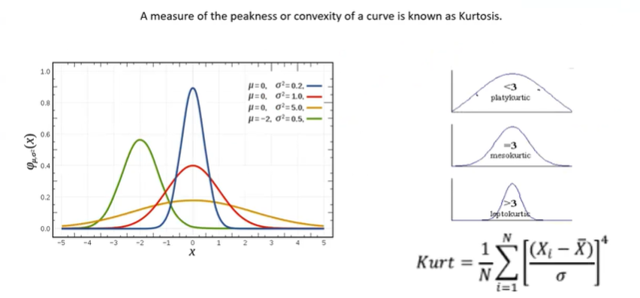

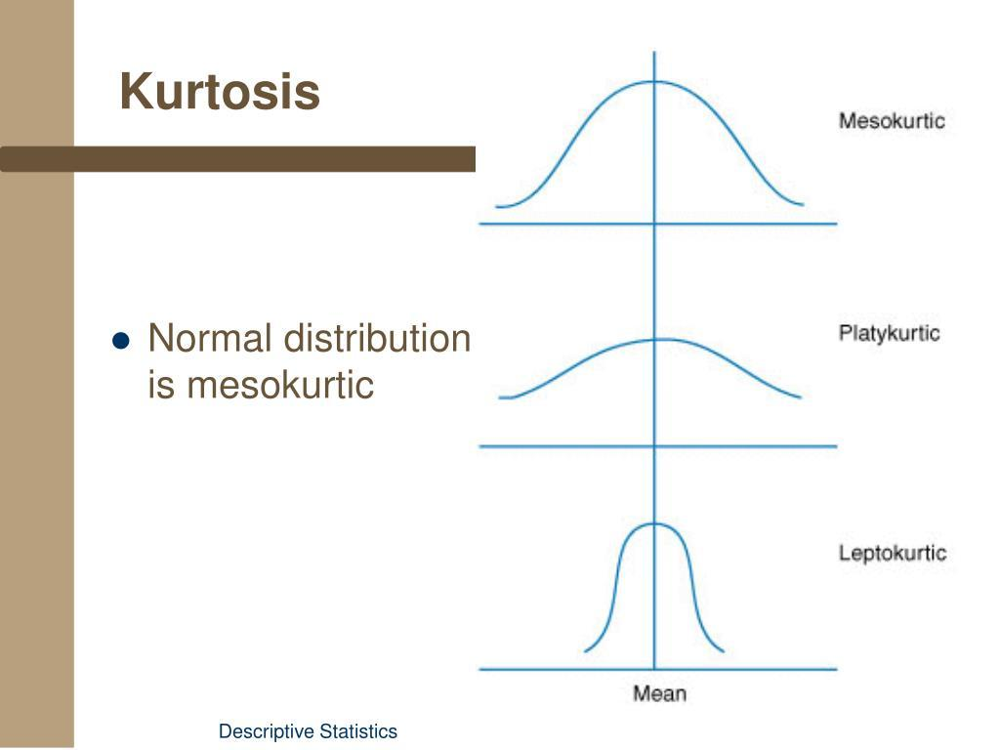

Types of Kurtosis
1. Mesokurtic (Normal Kurtosis)
- Similar to a normal distribution.
- Has a moderate peak and moderate tails.
- Few extreme values.
Kurtosis = 3
2. Leptokurtic (High Kurtosis)
- Heavier tails than a normal distribution.
- More likely to contain outliers.
- Often has a sharper central peak.
Kurtosis > 0
Example:
Dataset B
45, 48, 50, 51, 52, 53, 120
- The value 120 is an extreme outlier.
- High kurtosis (leptokurtic).
3. Platykurtic (Low Kurtosis)
- Lighter tails than a normal distribution.
- Fewer extreme values.
- Data is spread more evenly.
Kurtosis < 0
Example:
Dataset A
45, 48, 50, 51, 52, 53, 55
- No extreme values.
- Low kurtosis (platykurtic).

Comparison
Kurtosis Type | Tails | Outliers | Excess Kurtosis
Mesokurtic | Normal | Average | 0
Leptokurtic | Heavy | Many | > 0
Platykurtic | Light | Few | < 0

Skewness | Kurtosis
Measures asymmetry | Measures tail heaviness and outliers
Indicates left or right tilt | Indicates likelihood of extreme values
Positive, Negative, or Zero | Leptokurtic, Mesokurtic, Platykurtic

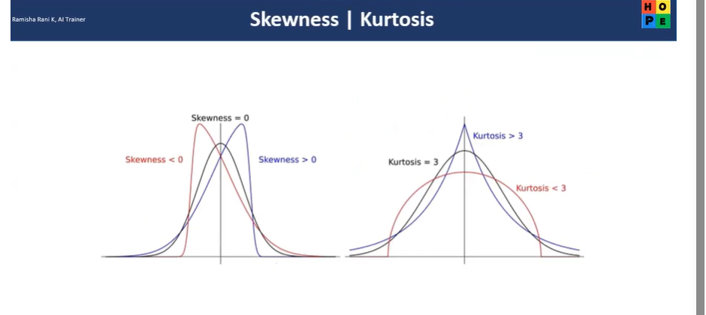
Importance of Kurtosis:
Kurtosis helps you:
- Detect whether a feature contains many outliers.
- Decide if outlier treatment is needed.
- Understand whether assumptions of statistical models (such as normality) are reasonable.
- Evaluate financial returns, manufacturing quality, and business metrics where rare extreme events matter.

Example from Your Placement Salary Dataset
Suppose most students receive salaries between ₹2.5 lakh and ₹4 lakh, but a few receive ₹20 lakh or ₹30 lakh packages.
- Skewness: The salary distribution is positively skewed because the high salaries pull the distribution to the right.
- Kurtosis: The distribution is leptokurtic because those very high salaries create heavy tails and increase the number of extreme values.
Trick to Remember
- Skewness = Which direction does the distribution lean? (Left or right)
- Kurtosis = How likely are extreme values? (Heavy tails or light tails)
A simple analogy is:
- Skewness tells you which way the data is leaning.
- Kurtosis tells you how extreme the unusual values are.

